Targeted Content Standard(s): |  | Student Friendly Learning Targets
G.SRT.3 Use the properties of similarity transformations to establish the AA criterion for two triangles to be similar  G.SRT.4 Prove theorems about triangles. Theorems include: a line parallel to one side of a triangles divides the other two proportionally, and conversely; the Pythagorean Theorem proved using triangle similarity. |  | I can…  - Use similarity transformations to verify AA similarity  - Use criteria for proving two triangles to be similar (AA, SAS, SSS for similarity)  - Use similarity to prove theorems about triangles including:  - Side-Splitter Theorem
Targeted Mathematical Practice(s):
1 Make sense of problems and persevere in solving them
2 Reason abstractly and quantitatively
3 Construct viable arguments and critique the reasoning of others
4 Model with mathematics
5 Use appropriate tools strategically
6 Attend to precision
7 Look for and make use of structure
8 Look for an express regularity in repeated reasoning
Supporting Content Standard(s): (optional)
Purpose of the Lesson:
The purpose of this lesson is to establish student understanding of similarity using various methods. This lesson includes explorations of similarity via transformations and the Pythagorean Theorem. Students will also verify criteria for triangle similarity, including AA, SAS, and SSS.

Explanation of Rigor: (Fill in those that are appropriate.)
Conceptual:  Use the properties of similarity transformations to establish the AA criterion for two triangles to be similar. | Procedural: |  | Application:  Prove theorems about triangles. Theorems include: a line parallel to one side of a triangle divides the other two proportionally, and conversely; the Pythagorean Theorem proved using triangle similarity.
Vocabulary:
Criteria for triangle similarity

- AA similarity
- SSS similarity
- SAS similarity
Side-splitter theorem
Pythagorean theorem (triangle similarity)

Evidence of Learning (Assessment):
Pre-Assessment:

Formative Assessment(s): Using Similarity Criteria (Segment 2), Side-splitter theorem (Segment 3), Varignon Quadrilateral (Segment 4)

Summative Assessment: Using Similarity Criteria (Segment 2)

Self-Assessment: Are they Similar? (Segment 1)

Lesson Segments:
- Use the properties of similarity transformations to establish the three criteria for two triangles to be similar.
- Using the criteria for triangle similarity (AA, SSS, SAS) to determine if two triangles are similar
- Prove that a line parallel to one side of a triangle will divide the other sides proportionally (and its converse).
- Prove that the quadrilateral formed by connecting the midpoints of consecutive sides of a quadrilateral (called the Varignon quadrilateral) is a parallelogram and will explore which quadrilaterals have specific Varignon quadrilaterals

Lesson Procedures:
Segment 1
Approximate Time Frame:  90-120 minutes | Lesson Format:  Whole Group  Small Group  Independent  Modeled  Guided  Collaborative  Assessment |  |  | Resources:  Are They Similar? assessment  Grid paper (dynamic geometry software can also be used)
Focus:  Use the properties of similarity transformations to establish the three criteria for two triangles to be similar. |  |  |  | Modalities Represented:  Concrete/Manipulative  Picture/Graph  Table/Chart  Symbolic  Oral/Written Language  Real-Life Situation
Math Practice Look For(s):  #2 Reason abstractly and quantitatively. Students will be able to use figures and information pertaining to a specific geometric object as an aid in reasoning about that geometric object in general.  #3 Construct viable arguments and critique the reasoning of others. Students will be able to create and present proofs, and be able to critique the proofs and deductive reasoning of others. |  | Differentiation for Remediation:  Differentiation for English Language Learners:  Differentiation for Enrichment:
Potential Pitfall(s):  May not understand/remember angle congruence  Difficulty calculating ratios |  | Independent Practice (Homework):
Steps:  - Review similarity  - What is sufficient to prove that two figures are similar?  - How do dilations play a part in two figures being similar? |  |  | Teacher Notes/Reflections:
- Students will be divided into groups of 2-3
  - Hand out Are They Similar? Assessment.
  - Explain that each student must complete the constructions (grid paper or dynamic geometry software).
  - Each group will fill out one activity.
  - Instruct students to work through each investigation.
- As groups finish, pair them up with other groups to share and discuss their findings. Have them make note of any discrepancies to later share with the whole class. |  |  | Teacher Notes/Reflections:
- Hold class discussion to summarize findings and discuss use of the triangle similarity criteria in a formal proof. Also discuss that AA similarity can be discovered by dilating a triangle with respect to a vertex of that triangle.

Segment 2
Approximate Time Frame:  45 minutes | Lesson Format:  Whole Group  Small Group  Independent  Modeled  Guided  Collaborative  Assessment |  |  | Resources:  Using Similarity Criteria assessment
Focus:  Using the criteria for triangle similarity (AA, SSS, SAS) to determine if two triangles are similar |  |  |  | Modalities Represented:  Concrete/Manipulative  Picture/Graph  Table/Chart  Symbolic  Oral/Written Language  Real-Life Situation
Math Practice Look For(s):  #1 Make sense of problems and persevere in solving them. Students will find missing measures in triangles given that two triangles are similar  #2 Reason abstractly and quantitatively. Students will be able to use figures and information pertaining to a specific geometric object as an aid in reasoning about that geometric object in general.  #4 Model with mathematics. Students will be able to solve a variety of problems that either involve or can be modeled with triangles by applying the properties of congruent and of similar triangles. |  | Differentiation for Remediation:  Differentiation for English Language Learners:  Differentiation for Enrichment:
Potential Pitfall(s): |  | Independent Practice (Homework):
Steps:  - Discuss the criteria discovered during the Are They Similar activity and how they can be used to identify similar triangles.  - Some example problems may be completed as a class  - Here is one possible example:  Determine if the two triangles are similar…  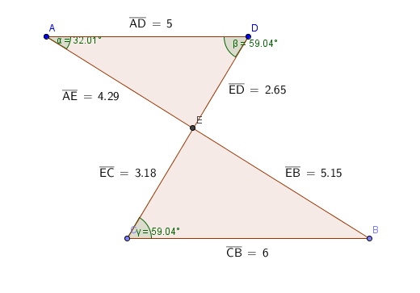 |  |  | Teacher Notes/Reflections:
- Present two similar triangles with a missing side length and have students work with a partner to come up with strategies to find the missing measure.  - Below is a possible example:  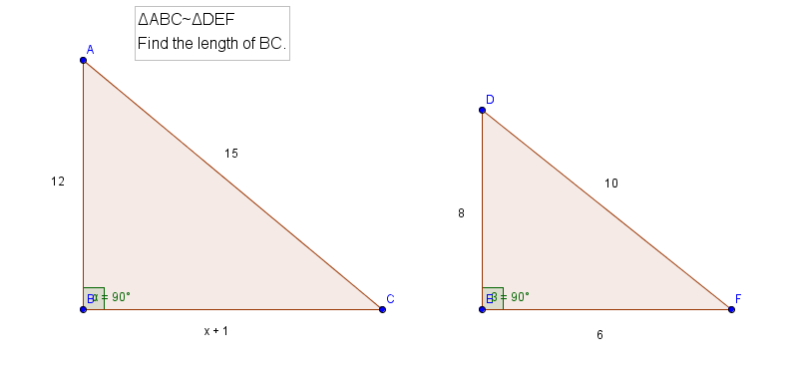  b. If a student uses Pythagorean Triples to solve, you may need to provide a second example with scalene triangles |  |  | Teacher Notes/Reflections:
- Hand out the Using Similarity Criteria assessment and have students work independently solving each problem.
  - Teacher can choose to circulate, have students share, or hold a class discussion after the activity.

Segment 3
Approximate Time Frame:  90 minutes | Lesson Format:  Whole Group  Small Group  Independent  Modeled  Guided  Collaborative  Assessment |  |  | Resources:  Side-Splitter Theorem assessment
Focus:  Students will prove that a line parallel to one side of a triangle will divide the other sides proportionally (and its converse). |  |  |  | Modalities Represented:  Concrete/Manipulative  Picture/Graph  Table/Chart  Symbolic  Oral/Written Language  Real-Life Situation
Math Practice Look For(s):  #2 Reason abstractly and quantitatively. Students will be able to use figures and information pertaining to a specific geometric object as an aid in reasoning about that geometric object in general.  #3 Construct viable arguments and critique the reasoning of others. Students will be able to create and present proofs, and be able to critique the proofs and deductive reasoning of others.  #4 Model with mathematics. Students will be able to solve a variety of problems that either involve or can be modeled with triangles by applying the properties of congruent and of similar triangles. |  | Differentiation for Remediation:  Differentiation for English Language Learners:  Differentiation for Enrichment:
Potential Pitfall(s): |  | Independent Practice (Homework):
Steps:  - Hand out Side-Splitter assessment. |  |  | Teacher Notes/Reflections:
- Complete exercises 1 and 2 as a whole group. Facilitate discussion to informally assess student understanding during this process.
- Direct students to work in pairs to complete exercise 3.
- Discuss exercise 3 as a group and how knowing properties of dilation makes the proof more concise.
- Complete examples of using the theorems to solve for a missing part of a triangle. Then, assign students to work individually on the remainder of the assessment. Monitor student successes. |  |  | Teacher Notes/Reflections:

Segment 4
Approximate Time Frame:  60-90 minutes | Lesson Format:  Whole Group  Small Group  Independent  Modeled  Guided  Collaborative  Assessment |  |  | Resources:  Varignon Quadrilateral assessment
Focus:  Students will prove that the quadrilateral formed by connecting the midpoints of consecutive sides of a quadrilateral (called the Varignon quadrilateral) is a parallelogram and will explore which quadrilaterals have specific Varignon quadrilaterals. |  |  |  | Modalities Represented:  Concrete/Manipulative  Picture/Graph  Table/Chart  Symbolic  Oral/Written Language  Real-Life Situation
Math Practice Look For(s):  #1 Make sense of problems and persevere in solving them. Students will recognize the hypothesis and conclusion in a proof statement and be able to generate the requisite proof using the given information in the proof statement, along with known facts, definitions, postulates, and theorems.  #2 Reason abstractly and quantitatively. Students will be able to use figures and information pertaining to a specific geometric object as an aid in reasoning about that geometric object in general.  #3 Construct viable arguments and critique the reasoning of others. Students will be able to create and present proofs, and be able to critique the proofs and deductive reasoning of others.  #6 Attend to precision. Students will recognize that incorrect initial attempts at definitions, conjectures, and theorems may be corrected through a process of refinement.  #7 Look for and make use of structure. Students will be able to use the structure of geometric objects to gain insights into, make conjectures about, and create proofs pertaining to these objects. |  | Differentiation for Remediation:  Differentiation for English Language Learners:  Differentiation for Enrichment:
Potential Pitfall(s):  Students may not recognize that a segment connecting the midpoints of two sides of a triangle divide those two sides proportionally (with ratio being 1:1), which is necessary in order to apply the converse of the Side-Splitter Theorem to complete this proof. Similarly, students may not recall the Midsegment Theorem, which can also be applied to complete this proof. |  | Independent Practice (Homework):  After being started in class, the exploration portion of the assessment where students conjecture about the properties that a quadrilateral must have in order to have a specific type of Varignon Quadrilateral could be left as homework.
Steps:  - Hand out Varignon Quadrilateral Assessment. |  |  | Teacher Notes/Reflections:
- Sketch a quadrilateral and its Varignon Quadrilateral, preferably using a dynamic geometry software so that it is easy to show students examples of Varignon Quadrilaterals for various different types of quadrilaterals.
- Sketch a diagonal of the original quadrilateral in your figure. Point how this diagonal divides the quadrilateral into two triangles where two sides of the Varignon Quadrilateral “split” the sides of these two triangles.
This would be a good time to remind students of the Side-Splitter Theorem (or the Midsegment Theorem) and ask them how it might be applied to this problem.
- Facilitate/guide students to an answer to question #3.
- Once question #3 is answered correctly, facilitate students group work through questions #4-#11
- Start students on exploration problems by asking them what would have to be true about a quadrilateral if its Varignon Quadrilateral is to be a rectangle.
- Facilitate student group work in completing explorations.
- Have students complete explorations either in class (time permitting) or as homework.
- Discuss answers to exploration questions.
As the exploration solutions are discussed, you may wish to questions students to get them to consider other possibilities, if students have not generalized their answers sufficiently (e.g., only considered parallelograms rather than general quadrilateral when considering solutions).

