Dear Family,

The Math 2 students are beginning to study *Unit 1: Extending the Number System*. Here is a little information about what your student will be learning in this unit.

**What is the Focus of this Unit?**

Students will extend the laws of exponents to rational exponents, and they will rewrite expressions involving radicals and rational exponents using these properties. The relationship of rational and irrational numbers will be explored by looking at their decimal representations. Students will also perform arithmetic operations on polynomials. Complex numbers will be introduced, and arithmetic operations will be explored.

At the end of this unit your student will be able to:

* Apply the properties of exponents to algebraic expressions with integer exponents.
* Apply the properties of exponents to algebraic expressions with rational exponents.
* Write radical expressions as expressions with rational exponents.
* Write expressions with rational exponents as radical expressions.
* Add, subtract, and multiply polynomials.
* Use the structure of an expression to identify ways to rewrite it.
* Perform arithmetic operations on complex numbers.

**What are the mathematical practice expectations for my student?**

* *Reason abstractly and quantitatively.* Students will use concrete examples of numerical manipulation to examine closure of rational and irrational numbers. For example, students will use numeric examples of sums and products of rational numbers to generalize the closure of rational numbers under addition and multiplication. Students will develop need for the complex number system.
* *Model with mathematics.* Students will use rational or radical expressions to represent mathematical models of real-world situations like interest rates or depreciation.
* *Look for and make use of structure.* Students will explore the relationship between radical and exponential notation.
* *Look for and express regularity in repeated reasoning.* Students will see that they are using the same procedures and properties for rational exponents as they used previously with integer exponents. In addition, they will apply previous knowledge of writing expressions in equivalent forms to operations with complex numbers.

**What types of problems should my student expect to solve?**

Sample Task #1

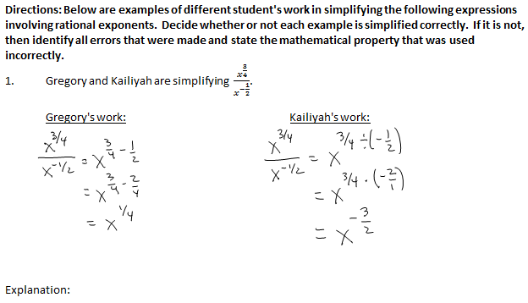

Sample Task #2

Ailey wants to start saving money to put a $1500 down payment on a car when she gets her driver’s license. She saw a commercial for Save-It-Now Bank that offers a savings account with an interest rate of 8% compounded annually. If it is 27 months until she can her license and she has $1000 to invest, write an expression to represent how much she will have for the down payment. Use the expression to decide whether or not this bank account will yield the amount she desires and explain your reasoning.

**How will my student apply what he/she learns in the future?**

Students will apply their knowledge of rational numbers and expressions with rational exponents to a real world context. These skills are relevant in many real world situations including solving problems involving loans, compound interest, and exponential growth and decay. Further, students will use their knowledge of complex numbers when finding solutions to quadratic equations.

**How can I help my student at home?**

* Ask your student to explain uses of vocabulary terms from this unit:

*Exponent, Linear, Rational, Exponential, Radical, Polynomial, Complex Number, Real number*

*Rational number, Irrational number, Integer, Sum, Product, Expression*

* Ask your student to describe how operations on radicals and rational exponents relates to previous work with integer exponents.
* Ask your student to explain to you the features of the different types of numbers, including natural numbers, whole numbers, integers, rational numbers, real numbers and complex numbers.
* Encourage your student to be persistent; make sure that he or she knows that mathematics requires patience, practice, and time to think and reflect. *
* Show interest for your student’s study of mathematics. Ask your student to explain solutions to problems. While correct answers are important, being able to explain reasoning is equally important.*
* Urge your student to ask the teacher questions either during or outside of class.*
* Encourage your student to review class notes frequently. *
* When your student doesn’t understand, a possible suggestion you can provide is to work backwards to determine how the solution was found.*
* Contact your student’s teacher for resources to support your student.

*\*adapted from* Council of the Great City Schools. (2014). Parent Roadmap: Supporting your child in high school mathematics. Retrieved from http://www.cgcs.org/cms/lib/DC00001581/Centricity/Domain/36/ParentGuide_Math_HS_Final.pdf