Chicago’s Early College STEM Schools

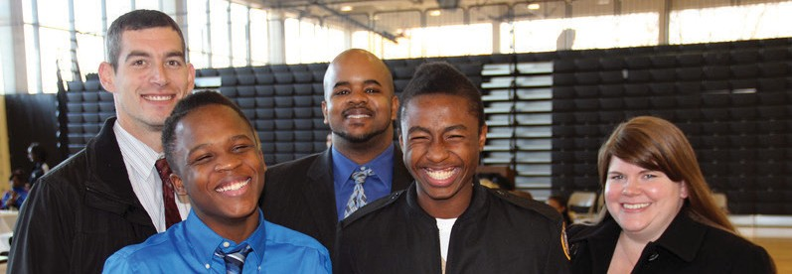
EAR LY COLLEGE

Powered by the IL IT Learning Exchange

During Q2 2014, there were 648,016 IT job openings in the US, according to Burning Glass Technologies Labor Insights.

IT postings represent 11% of all job openings.

IT postings have grown by 35% over the same Q2 last year.

“According to a STEM state-level analysis by Georgetown University, Illinois will demand a total of 300,000 STEM jobs by 2018, up nearly 20% from 2008. 93% of these will require post-secondary education and training by 2018.”

“Talent shortages continue to persist and are impeding employers’ ability to deliver
value for their customers,” said Jonas Prising, ManpowerGroup CEO. “Due to the lack of applicants with the right technical competencies, experience and soft skills, one out of three employers struggle to fill open roles. For nearly a decade STEM positions are among the top 10 hardest jobs to fill.”

INFORMATION TECHNOLOGY STARTING SALARIES – CHICAGO, IL
In 2012, five Early College STEM Schools (ECSS) were formed by the Mayor’s office, CPS and City Colleges of Chicago, to dynamically connect high school students with college and career. In partnership with private corporate sponsors, a unique model has been designed to ensure students have the education and skills needed to pursue
a career in technology after graduation. Within this model, Early College STEM school students, during their high schools years, have the opportunity to simultaneously earn their high school diploma, Associate’s Degree, and IT industry certifications. To narrow the gap between theory and practice, corporate sponsors extend
the classroom into the workplace, connecting students’ acquired knowledge with future employment opportunities.
CPS, City Colleges of Chicago and CompTIA, through the Illinois IT Learning Exchange, are providing resources to support
the implementation of this model and work-based learning opportunities. These resources include mentoring programs, internships, expanded classroom projects, and other experientially- based industry engagements that provide students with significant work experience prior to graduation. This equips students with
the skills needed to pursue careers within a technology-driven workforce, and accelerates their readiness for 21st century careers.

ECSS IT Curriculum
IT CAREER PATHWAYS | CERTIFICATION(S) | TARGET DEGREES (AS/AAS)
Networking | CompTIA A+, Cisco | AAS
Web Development |  | AAS/AS
Computer Programming |  | AS

Desktop Support Analyst . . . . . . . . . . $61,192 - $89,790 Software Developer . . . . . . . . . . . . . . .$98,708 - $156,518 Mobile Applications Developer . . .$123,000 - $177,120 Chief Technology Officer . . . . . . . . .$162,668 - $253,072

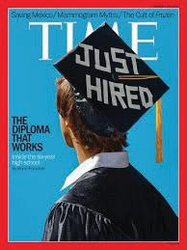
Highlights: Chicago’s Early College STEM Schools
- SeaPerch underwater robotics program launched in January

- TIME Magazine’s cover story on February 13, 2014, “The School that will get you a Job.”
- Launched project-based learning with Motorola Solutions and R&D Learning Exchange (Mobile App Development)
- STEM labs being rebuilt, summer 2014

- Hosted visits by US Secretary of the Navy, US Secretary of the Interior; principal and student met President Obama
- Planned project-based learning with Lumity and CDW (Project: Instigating School Improvements through Crowdsourcing)
- Hackathon Group Mentoring Event at Microsoft

SCHOOL | SPONSOR | COMMUNITY COLLEGE PARTNER | SIZE OF IT PROGRAM (ENTIRE SCHOOL OR PORTION) | NUMBER OF STUDENTS (EST. FALL 2014)
Michelle Clark | Cisco | Malcolm X | Entire School | 430
George Corliss | Verizon | Olive Harvey | Entire School | 270
CVCA | Motorola | Olive Harvey | Select Students | 360
Sarah Goode | IBM | Daley | Entire School | 490
Lake View | Microsoft | Wright | Select Students | 270

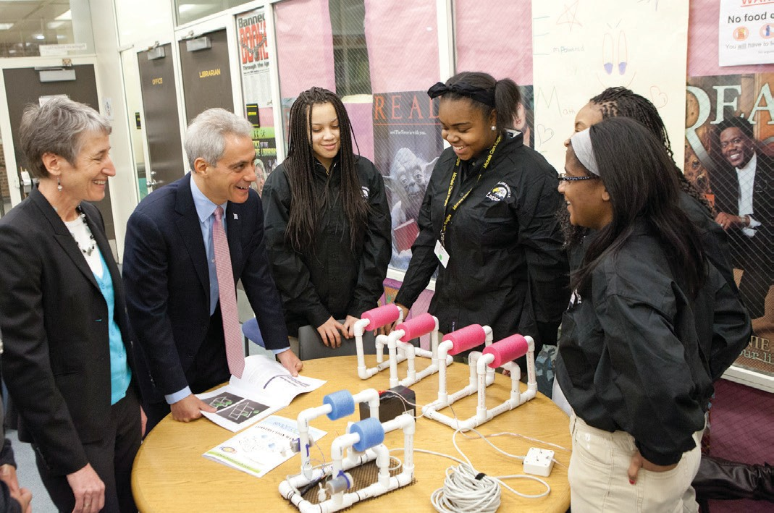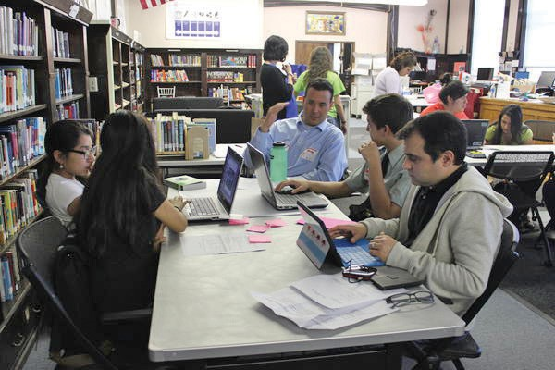

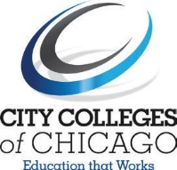
EAR LY COLLEGE

